**Assignment-11**

1. **Acquire Data and Start the Story**

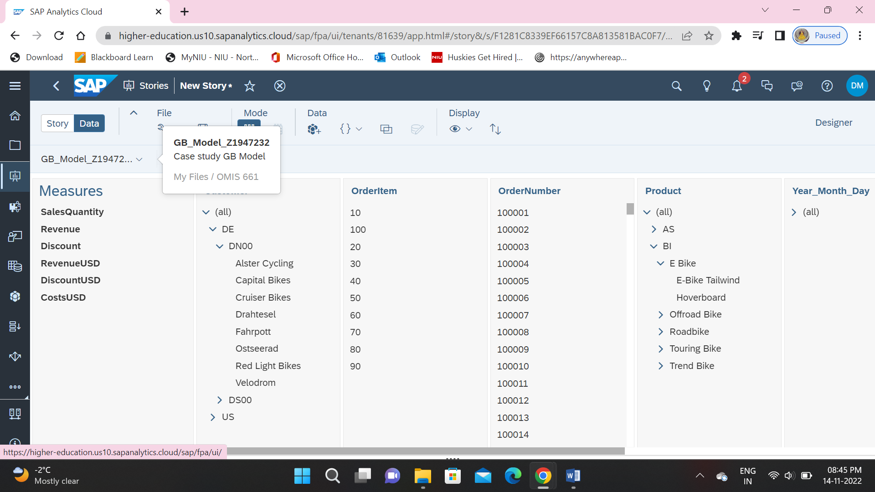

1. **Create a Geo-Map Page of Revenues in the United States**

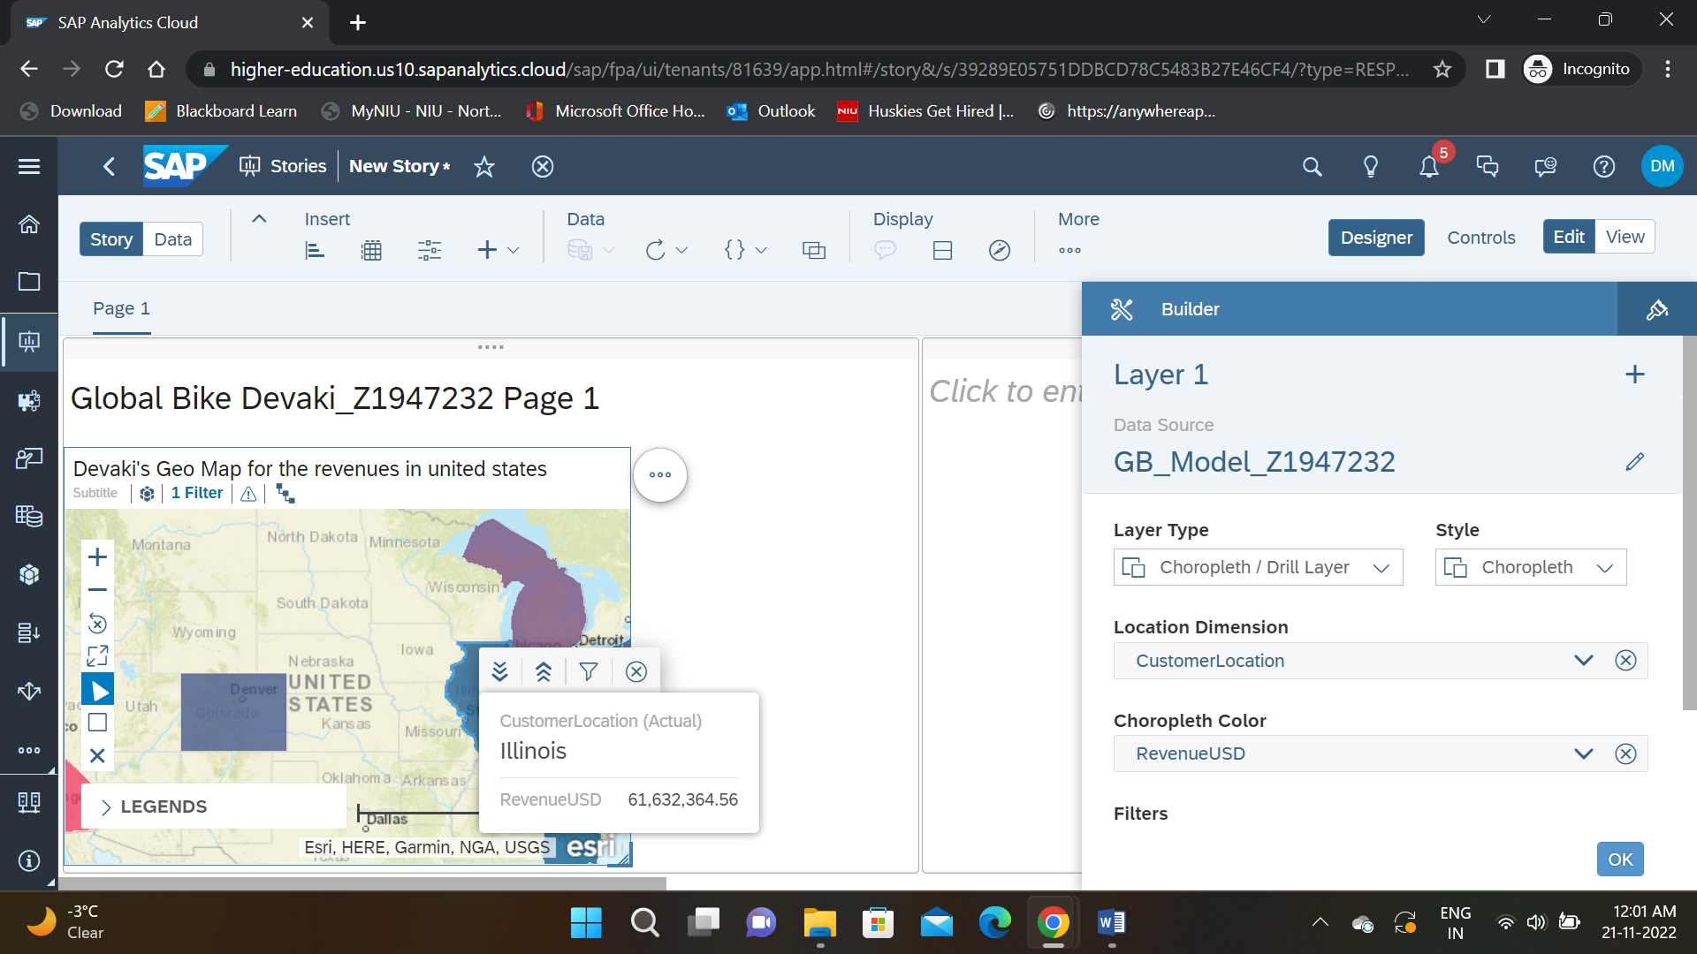

1. **A Geo Map with Two Layers**

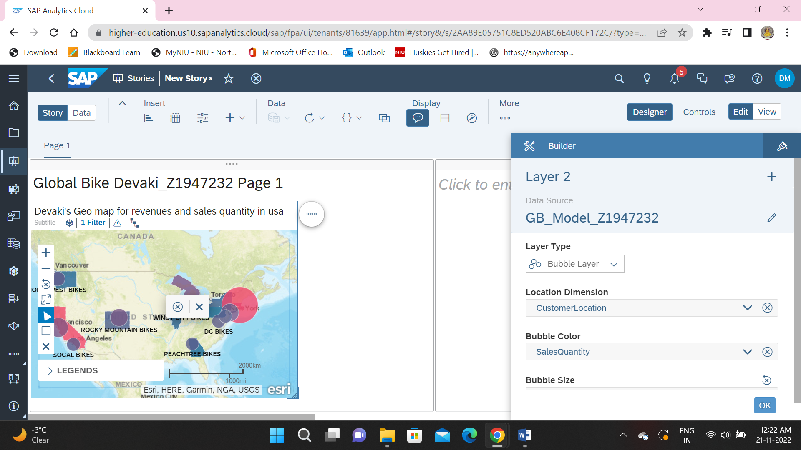

1. **Adding a Comment to a Chart**

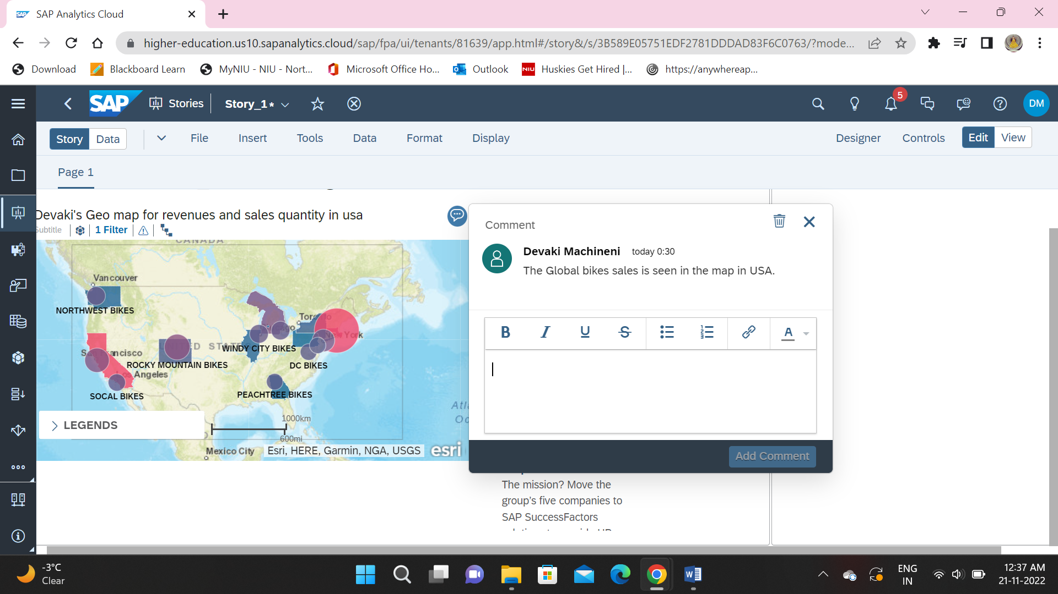

1. **Input control**

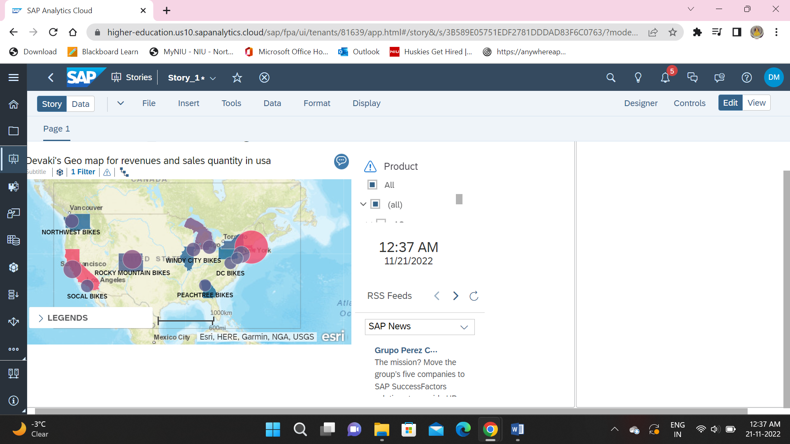

1. **Demonstration of Linked Analysis**

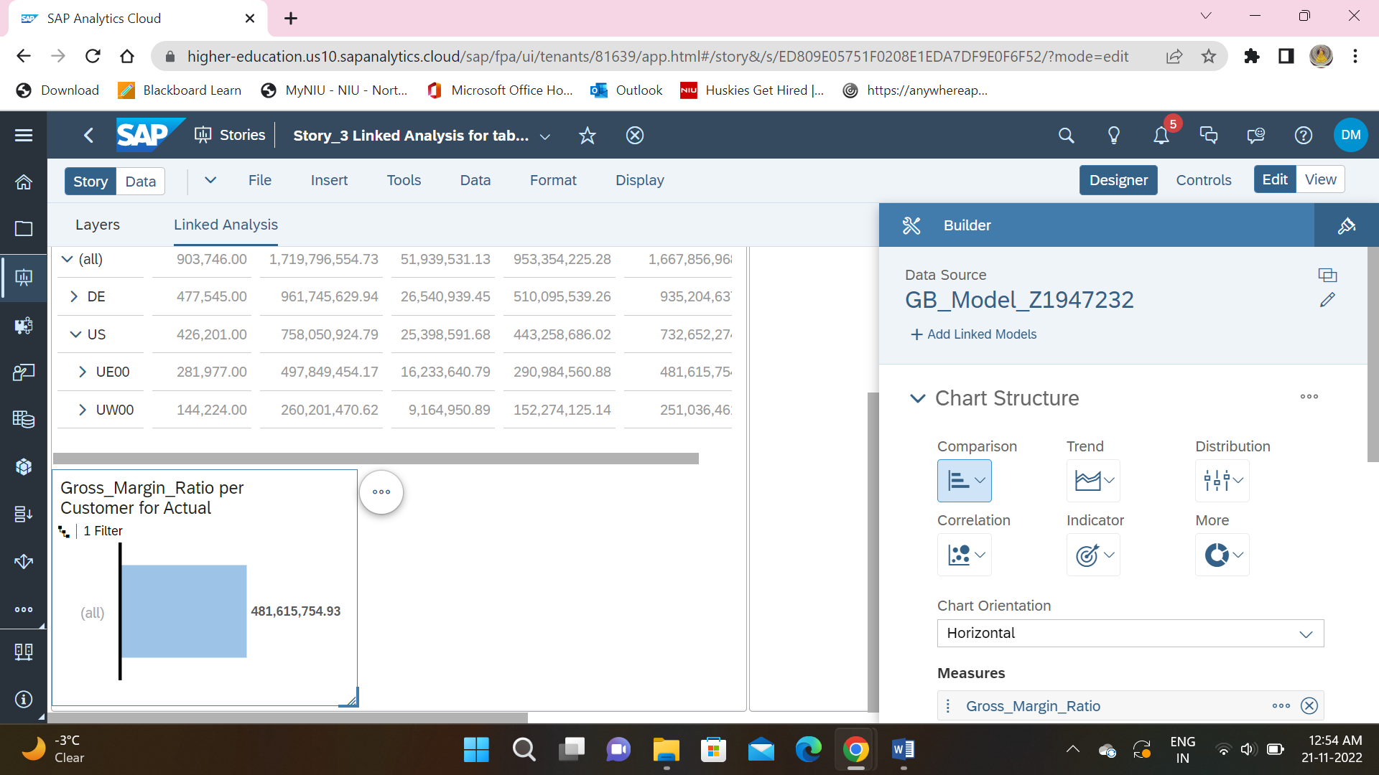

1. **Customer Bullet Chart**

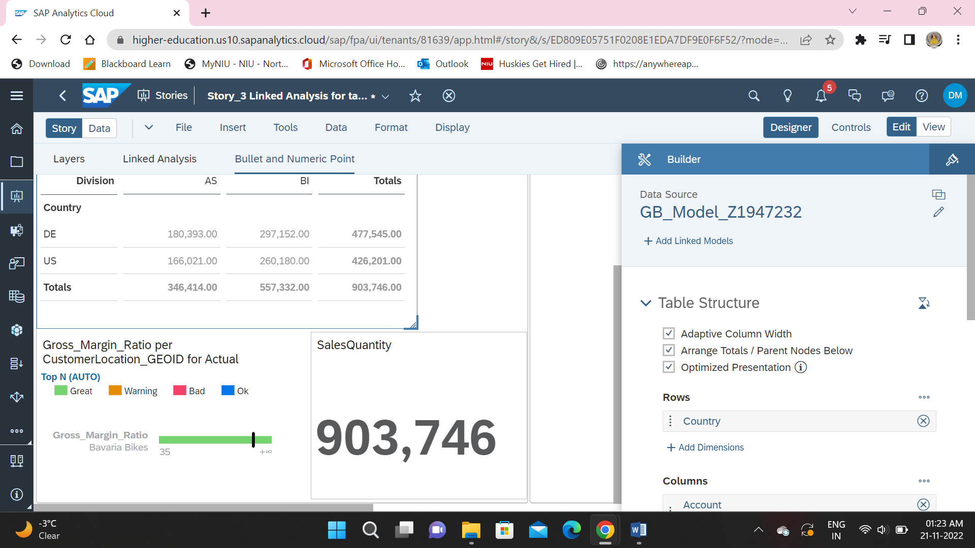

1. **Time Series**

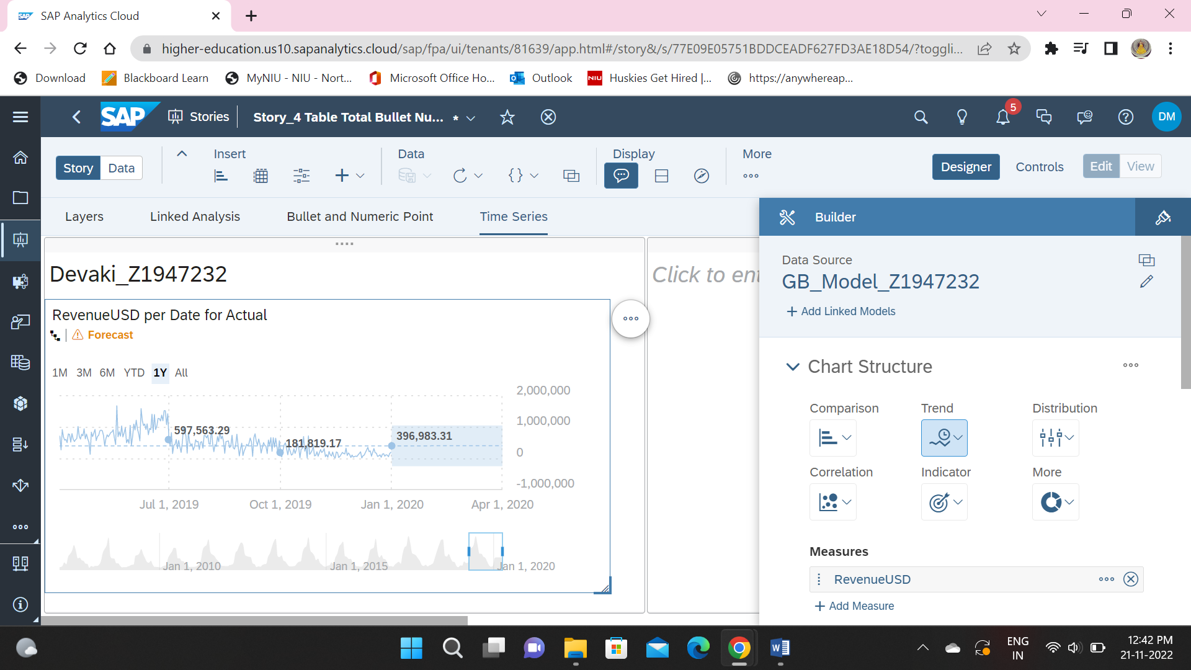

1. **Variances**

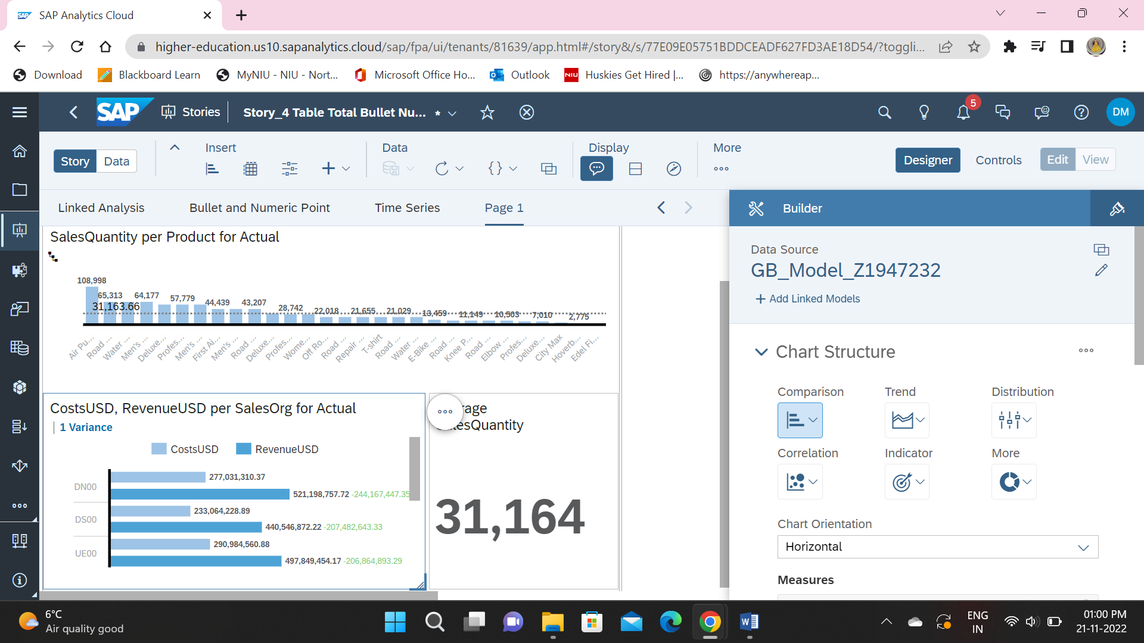

**Bubble Chart of Quantity, Revenue, Gross Margin Ratio by Customer in 2019.**

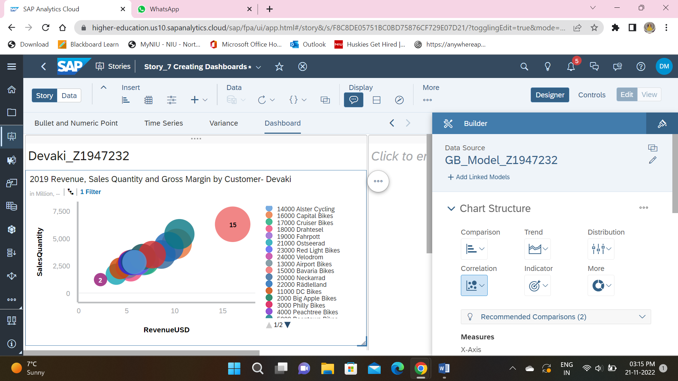

1. **Smart Grouping**

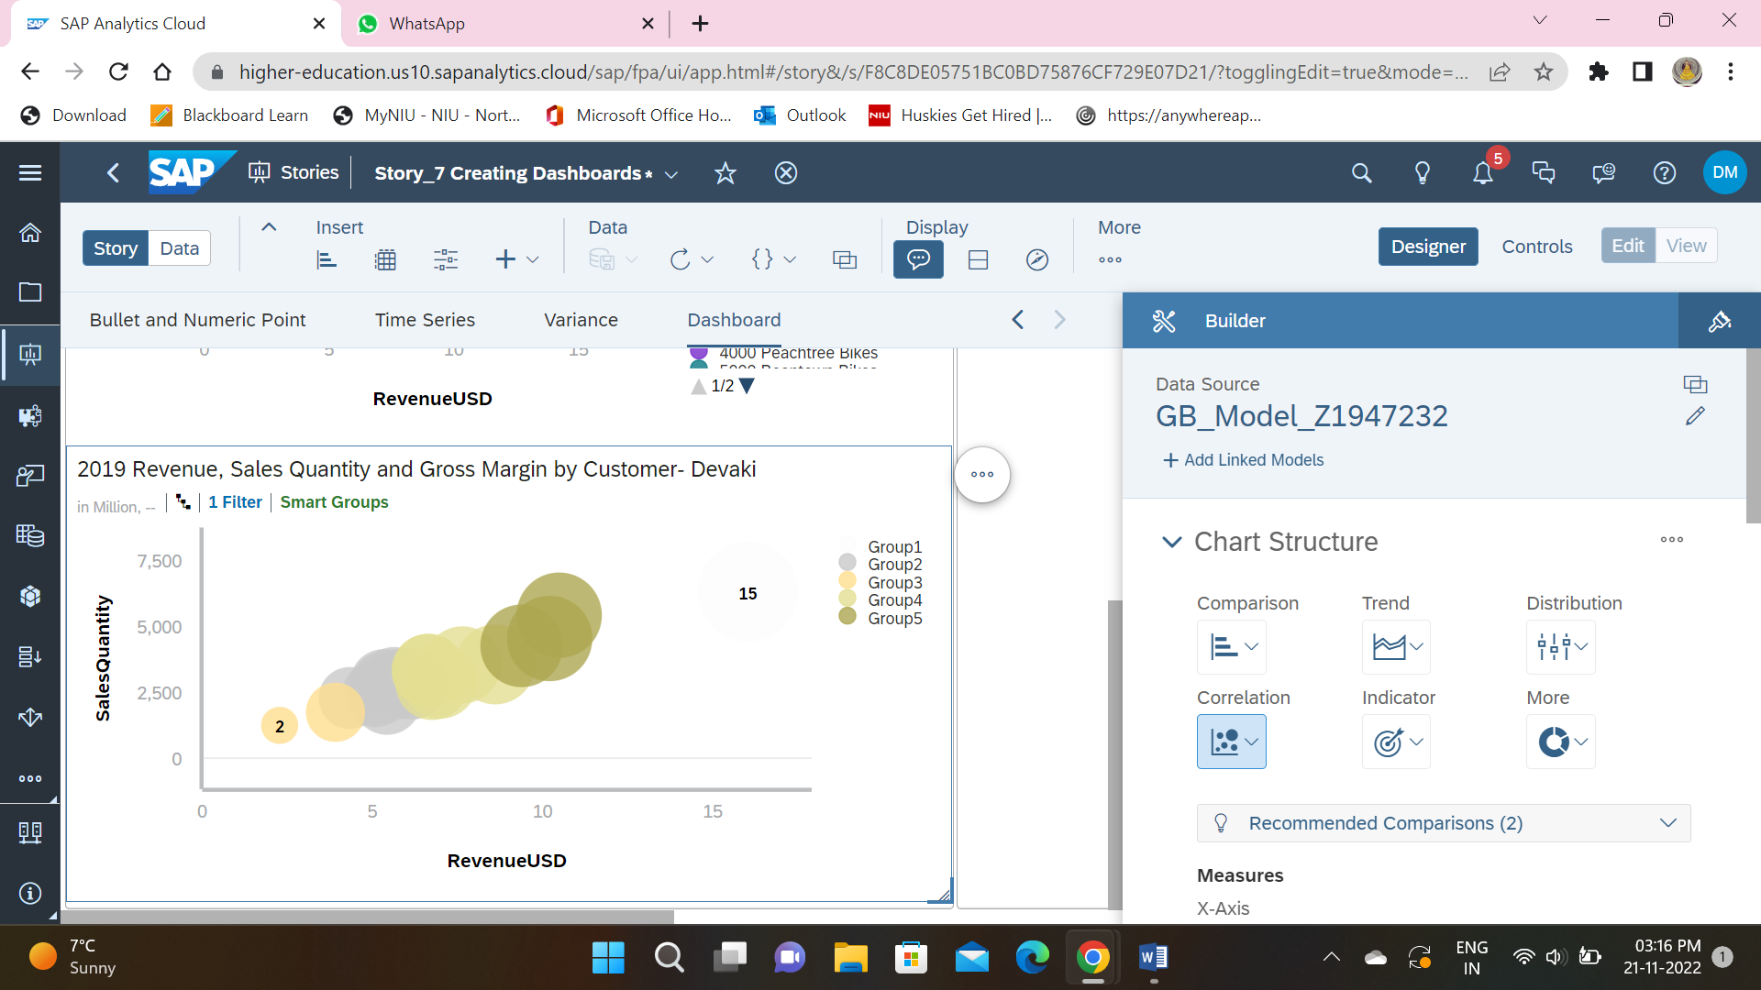

**Story link:**

https://highereducation.us10.sapanalytics.cloud/sap/fpa/ui/tenants/81639/bo/story/F8C8DE05751BC0BD75876CF729E07D21